Creating a Termbase with TBX

Introduction

What is TBX?
TBX (TermBase eXchange) is family of XML-based languages for the interchange of terminological information. Each language is referred to as a “TML”, for Terminological Markup Language. All of TBX shares a common core structure, in which information is represented hierarchically in three levels:
- Concepts
- Languages
- Terms
Concept entries contain language entries, which in turn contain entries for individual terms. The core structure also provides ways for adding descriptive and administrative information to each entry.

What Does TBX Look Like?
Don’t panic! If you don’t want to see this ugliness, you don’t have to. Just skip to section 1.4.
Here is an example from TBX-Basic, a TML in the TBX family intended to provide the data categories most commonly used in translation and localization work:
<termEntry id="C005">
<langSet xml:lang="en">
<tig id="C005en1">
<term>chick peas</term>
<termNote type="partOfSpeech">noun</termNote>
</tig>
<tig id="C005en2">
<term>garbanzo beans</term>
<termNote type="partOfSpeech">noun</termNote>
</tig>
</langSet>
<langSet xml:lang="fr">
<tig id="C005fr1">
<term>pois chiches</term>
<termNote type="partOfSpeech">noun</termNote>
</tig>
</langSet>
</termEntry>

It Looks Complicated…
Let me explain: in XML, we mark information with tags, which are enclosed in pointed braces (<>). A start tag (<tagName>) and an end tag (</tagName>) are always matched, and they surround the text they are meant to describe. Here, we have <termEntry>, containing a concept, <langSet>, containing a language, and <tig>, containing information pertaining to a single term, as well as other tags.
XML tags may also have attributes (attribute=”value”). The only attributes used in this example are xml:lang (specifying a language by a standard abbreviation) and id (assigning a unique ID to a term).
So the example above may more simply be described like this: concept C005 can be expressed in French as “pois chiches” (a noun), or in English as “chick peas” (another noun) or “garbanzo beans” (yet another noun).

Too Much Work. Why Bother to Write All That XML?
- TBX is an international standard- the use of TBX is becoming more and more ubiquitous in translation software. If you use a proprietary format to store your translation glossary, your data may be forever stuck in that software. Protect your work by using a portable, standardized format.
- TBX has Blind Interchange as its goal- You should be able to send your glossaries to clients, employees and colleagues without worrying about whether or not they can use it. Everything they need should be right there in the glossary.
- You probably don’t need to edit it by hand anyways. There’s a lot of terminology management software out there that will export in TBX format for you! If you really need to edit it by hand, then you can also try the more readable MRC format (explained in this tutorial).

Can I Still Use SDL MultiTerm?
Of course! In this document, we’ll show you how to export TBX files from MultiTerm.

I’d Like to Work With TBX by Hand, but I Don’t Like XML
That’s why there’s MRC format, a more human-readable version of TBX-Basic. We’ll cover that, too.

Oh Look, MultiTerm has a TBX Export Function…
No, don’t! You’ll regret it! MultiTerm does not output real TBX. It’s just XML that resembles TBX. We provide a tool that converts the MultiTerm database into TBX for you. Annoyed at MultiTerm? Maybe SDL will fix it if they get enough emails about it. Send an email to multiterm.tbx.request@gmail.com and we’ll make sure they get the message.

Creating a TBX Termbase

Using MultiTerm
To reiterate what was said above: MultiTerm’s TBX export functionality is imperfect. Instead, you need to export it in MultiTerm’s special XML format, and then use our tool to convert it. First, one caveat:
- You will have to do some special finagling if you didn’t use one of MultiTerm’s default formats (bilingual glossary or multilingual termbase). The nature of the “finagling” is explained in full on the conversion website, but it does become somewhat technical at times. Be prepared!

Exporting a Termbase from Multiterm
If you used one of the default MultTerm layouts, then this should be fairly straightforward. First, export your glossary from MultiTerm like so:
- Click on “Catalog” on the left column of options:
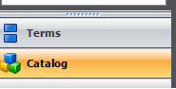

- Click on “Export” on the left side options that appear:
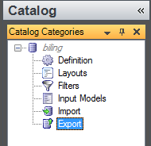

- In the middle is your list of export options, select “default export definition”:
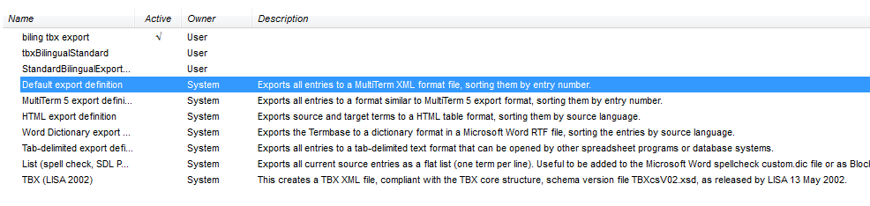
- Right click on “Default export definition” and select the process option:

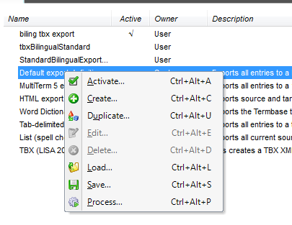
- Click on the “Save as…” option to select where you will save the file, and then follow the wizard directions until you have the XML file:
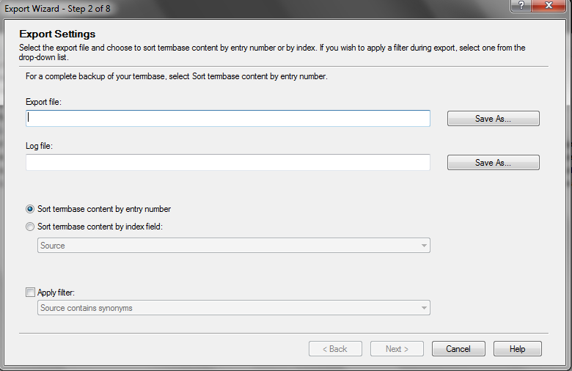

Converting the MultiTerm Data into TBX
Next, visit our website to convert your data into TBX: [tbxconvert.gevterm.net/mt2tbx/index.html]. Notice that the directions there tell you to choose a mapping file. A mapping file is what determines how your MultiTerm data will be rendered as TBX. There is a downloadable mapping for the default MultiTerm termbase types (bilingual glossary or multilingual termbase). If you didn’t use MultiTerm’s default termbase types, you’ll have to follow the direction and make your own.
Next, click on the link to the conversion script page (shown below). Choose your MultiTerm file and the mapping file you are using (probably downloaded from the previous page) and then click “submit”. Your new TBX termbase will be downloaded immediately!
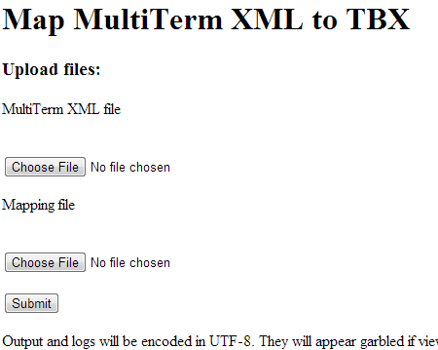

Working with MRC Instead
MRC editing is not, as of now, supported by any known CAT software. MRC is for the times when you would like to create a TBX document from scratch without software. MRC, which stands for “Multiple Rows per Concept”, is a much more user-friendly format. Instead of being organized through XML tags, it is simply formatted into rows.
On our website you will find tutorials, examples and other resources for using the MRC format [http://tbxconvert.gevterm.net/mrc2tbx/mrcInfo.html], but we’ll show an example here. The table below contains a complete MRC document:

=MRCtermTable
A | workingLanguage | en
A | sourceDesc | a restaurant menu in English and French
C003 | subjectField | Restaurant Menus
C003fr1 | term | poulet
C003fr1 | partOfSpeech | noun
C003fr1 | grammaticalGender | masculine
C003en1 | term | chicken
C003en1 | partOfSpeech | noun

Explanation of Example
The first column contains concept, language and term IDs (‘A’ just means that the row applies to ‘All’ data in the termbase). The second column names the type of data being specified, and the third column contains the actual data. You can ignore the first row, which is required in every MRC file. You can use a plain text editor or your favorite spreadsheet program to edit MRC files. Please take a moment to download the sample Excel MRC file from our website.
The data types allowed are limited, so make sure to check the original MRC documentation to learn what is valid MRC (located here:[http://www.ttt.org/tbx/AKMtradumaArticle-publishedVersion.pdf]).

Converting to TBX-Basic
We provide a tool to convert MRC files into TBX-Basic. The tool can be used online here: [http://tbxconvert.gevterm.net/mrc2tbx/index.html] (shown below).
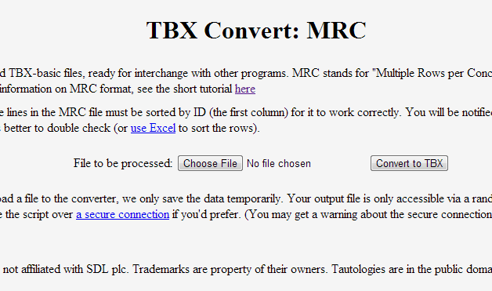
In order to use this, your file must be plain text, with rows separated by tab characters. When we convert the complete MRC file shown in the table above, we get something like this for the concept:
<termEntry id="C003">
<descripGrp>
<descrip type="subjectField">Restaurant Menus</descrip>
</descripGrp>
<langSet xml:lang="fr">
<tig id="C003fr1">
<term>poulet</term>
<termNote type="partOfSpeech">noun</termNote>
<termNote type="grammaticalGender">masculine</termNote>
</tig>
</langSet>
<langSet xml:lang="en">
<tig id="C003en1">
<term>chicken</term>
<termNote type="partOfSpeech">noun</termNote>
</tig>
</langSet>
</termEntry>
There’s our good ol’ XML format, ready for interchange. Now you can create TBX data from scratch without touching XML!

